Terraform Task

Launch Linux EC2 instances in two regions using a single Terraform file.

Main.tf created

Terrraform Initiated
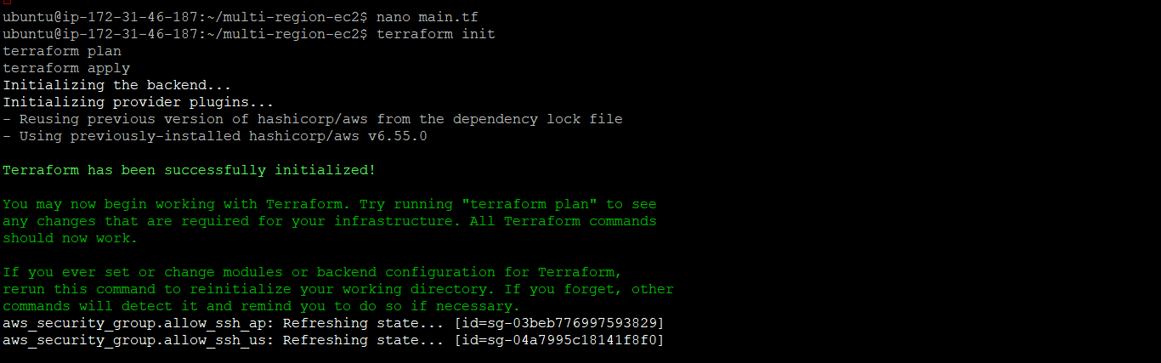

Output :

EC2 created in 2 different regions
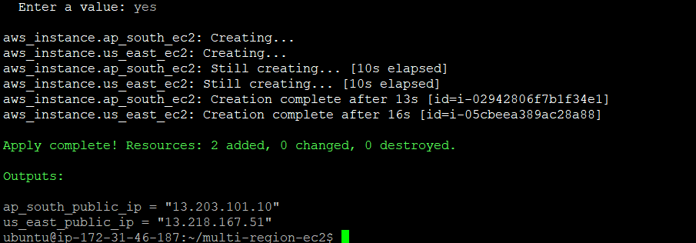

South region EC1 from Console :

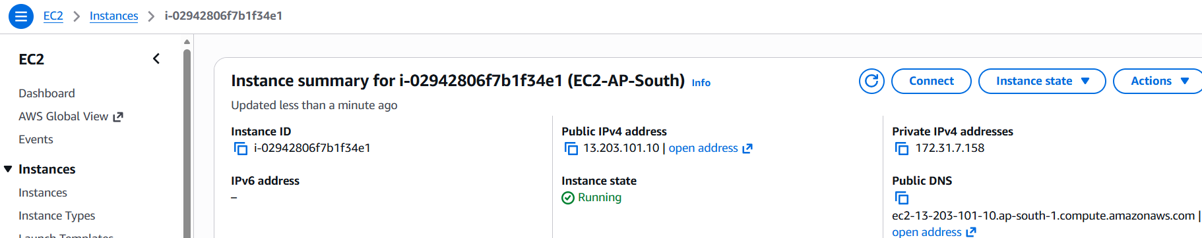

US region EC2 from console:

